NHS A&E Performance Dashboard (Power BI)
Project Overview
This project presents an interactive Power BI dashboard developed to analyse NHS Accident & Emergency (A&E) performance data. The dashboard provides insights into patient demand, waiting time performance, hospital comparisons, and regional variations.
The aim of this project is to demonstrate how healthcare data can be transformed into clear and meaningful insights to support performance monitoring, operational decision-making, and improved understanding of healthcare services.

Project Objectives
The main objectives of this project were to:
- Analyse A&E attendance trends over time
- Monitor performance against the four-hour waiting time target
- Compare performance across NHS regions
- Identify hospitals with higher and lower performance levels
- Develop an interactive dashboard for healthcare performance analysis

Dataset
The dataset contains NHS A&E performance information, including:
- Hospital names
- NHS regions
- Monthly A&E attendance figures
- Patients treated within the four-hour target
- Waiting time performance indicators
- Performance trends over different reporting periods
The dataset is used for educational and portfolio purposes.

Tools & Technologies Used
- Power BI Desktop – Dashboard development and data visualisation
- DAX – Creating calculated measures and performance indicators
- Power Query – Data cleaning and transformation
- Microsoft Excel – Data preparation and initial review
- SQL – Data analysis and querying

Data Analysis Process
1. Data Preparation
The dataset was prepared for analysis by:
- Importing NHS healthcare data into Power BI
- Cleaning and transforming data using Power Query
- Removing inconsistencies and improving data quality
- Preparing fields for analysis and reporting
2. Data Modelling
A structured data model was created by:
- Building relationships between data tables
- Organising data for efficient analysis
- Creating calculated measures using DAX
3. Dashboard Development
An interactive dashboard was developed with visualisations including:
- KPI cards showing key performance indicators
- Monthly attendance trend analysis
- Four-hour waiting time performance tracking
- NHS regional comparisons
- Top and bottom hospital performance rankings
- Interactive filters and slicers for detailed exploration

Dashboard Features
Key Performance Indicators
The dashboard highlights:
- Total A&E attendances
- Average four-hour performance
- Number of hospitals analysed
- Regional performance overview
Visualisations
The dashboard includes:
- Line charts to show performance trends over time
- Bar charts for hospital comparisons
- Maps for regional analysis
- Tables showing detailed hospital rankings

Key Insights
The dashboard helps users understand:
- Changes in A&E demand over time
- Differences in performance between hospitals
- Regional variations in waiting time performance
- Areas where further operational review may be required

Dashboard Preview
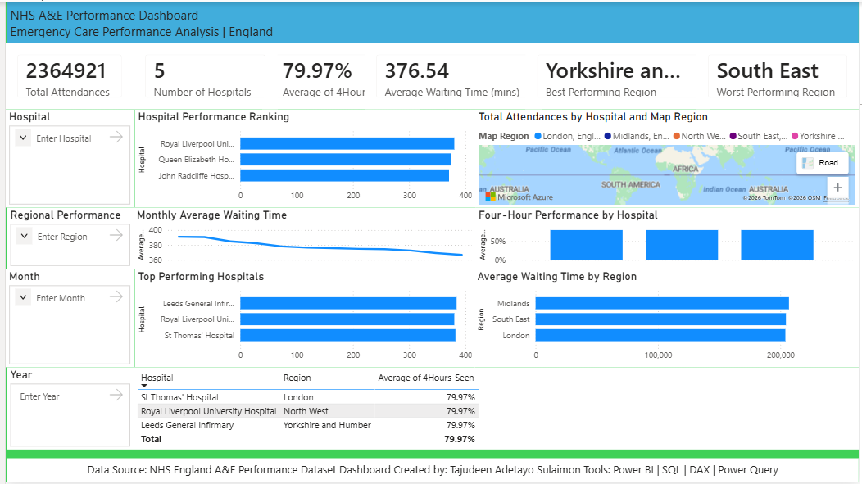

Project Structure
NHS-AE-Performance-Dashboard
│
├── NHS_AE_Performance_Dashboard.pbix
├── Dashboard Screenshot.png
├── Dataset.csv
└── README.md

Skills Demonstrated
- Data Cleaning and Transformation
- Data Modelling
- DAX Measures
- Healthcare Analytics
- Power BI Dashboard Development
- Data Visualisation
- Business Intelligence Reporting

Contact
GitHub: https://github.com/sulaimonta/tajudeen_data-analyst-portfolio
LinkedIn: https://www.linkedin.com/in/tajudeen-sulaimon-7a3642189/

